This document provides a guideline to the possible users of the SkillCourt system.

SkillCourt

Coach User Guide

Erico Oyarzun

Andres Ruggiero

Table of Contents

1. Introduction 2

Getting Started 3

Creating an account 3

Log In 5

As a User 5

As a Coach 7

Sign or Release a Player 8

Assign or un-assign a Player 9

Delete or Edit a Routine 11

Create a Custom Routine 13

User Account Information 15

Forget Password or Username 15

# 1. Introduction

While many areas have integrated technological advances gracefully, others lack the ability to assimilate technology with traditional techniques. Soccer is an area that has been unable to embrace technological advancements with the traditional game.

Soccer is a team-focused sport that has only one coach dedicated to the entire team, and the problem arises when players want to train & improve individual weaknesses. Moreover, the infrastructure requirements are very expensive because the need for a physical field.

For these reasons, soccer training can be a very cumbersome feat for the average person. Without proper guidance, progression dwindles and a person may not feel obligated to continue. It is essential for players to develop a body-mind coordination that allows them to move and perform specific techniques.

SkillCourt system tries to address this problem by providing players with the ability to improve their skills by interacting with it in a one-to-one manner.

The purpose of this document is to explain how the different users can interact with the new system.

# Getting Started

1. To access the SkillCourt website type the following URL in your web browser:

<http://www.skillcourt.com>

### Creating an account

As a new user, you should first create an account. The two possible actors in the SkillCourt system are players and coaches.

1. In the Main Page, click on the “Register Now” button. This should redirect you to the sign up page.

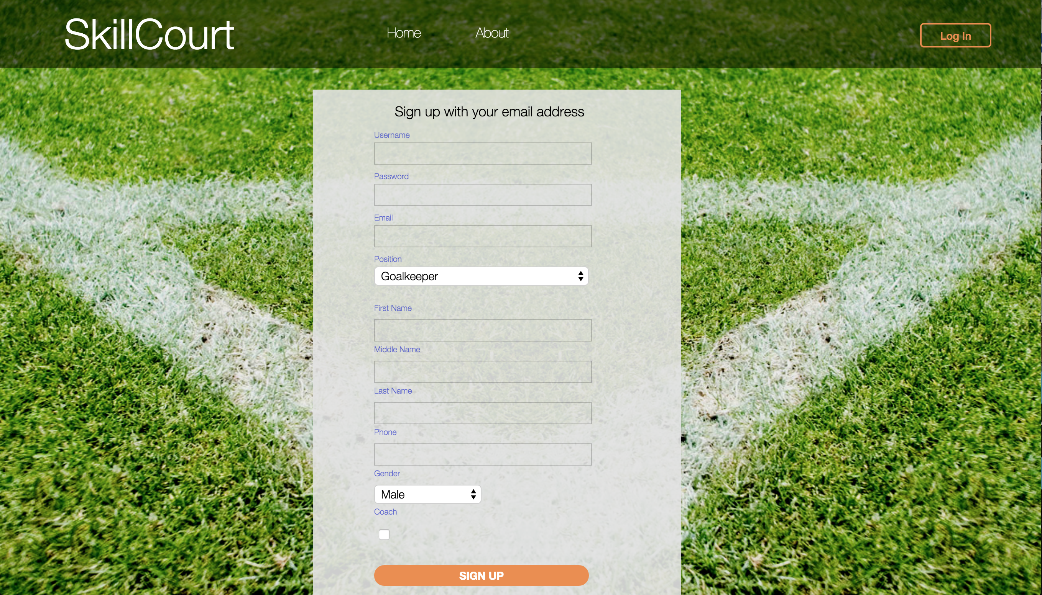

1. Fill In the proper account information. Please note that email address and username have to be unique. If you want to create a player’s account, leave the “Coach” checkbox unchecked.

# Log In

### As a Coach

1. In the Main Page, click the “log In” button in the navigation bar. This should redirect the user to the Log In Page.

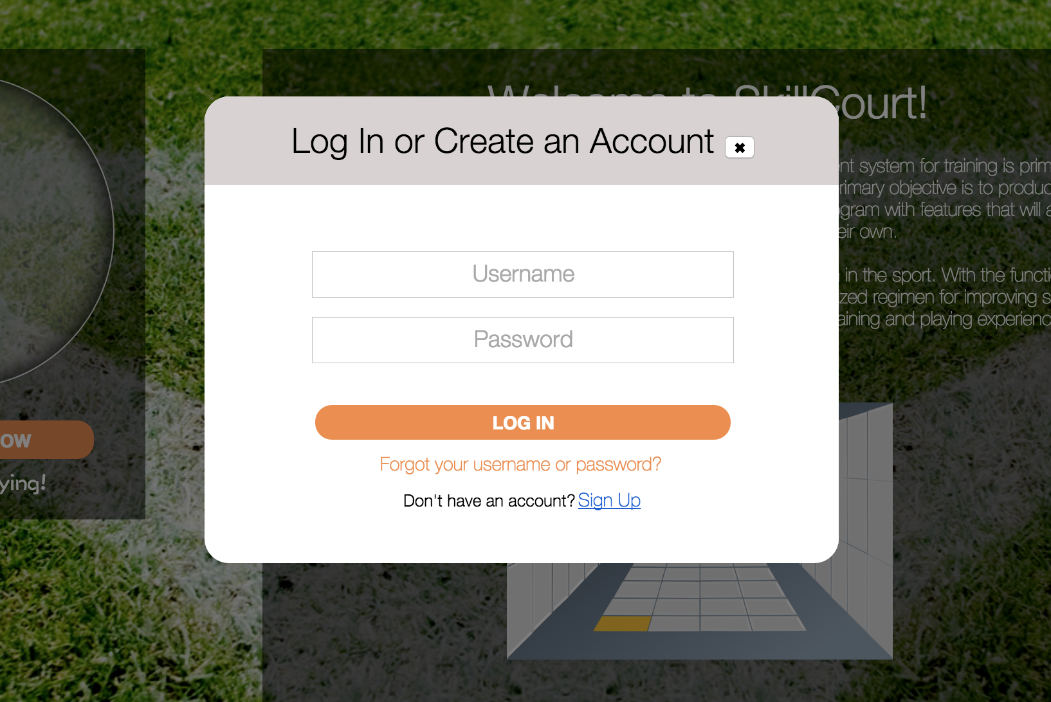

1. Type in your username and password and click the “LOG IN” button. This should redirect the user to the Coach Main Page.

#### Sign or Release a Player

1. The coach has the ability to sign a player to. To sign or release a player, first click on the Players tab on the navigation bar.

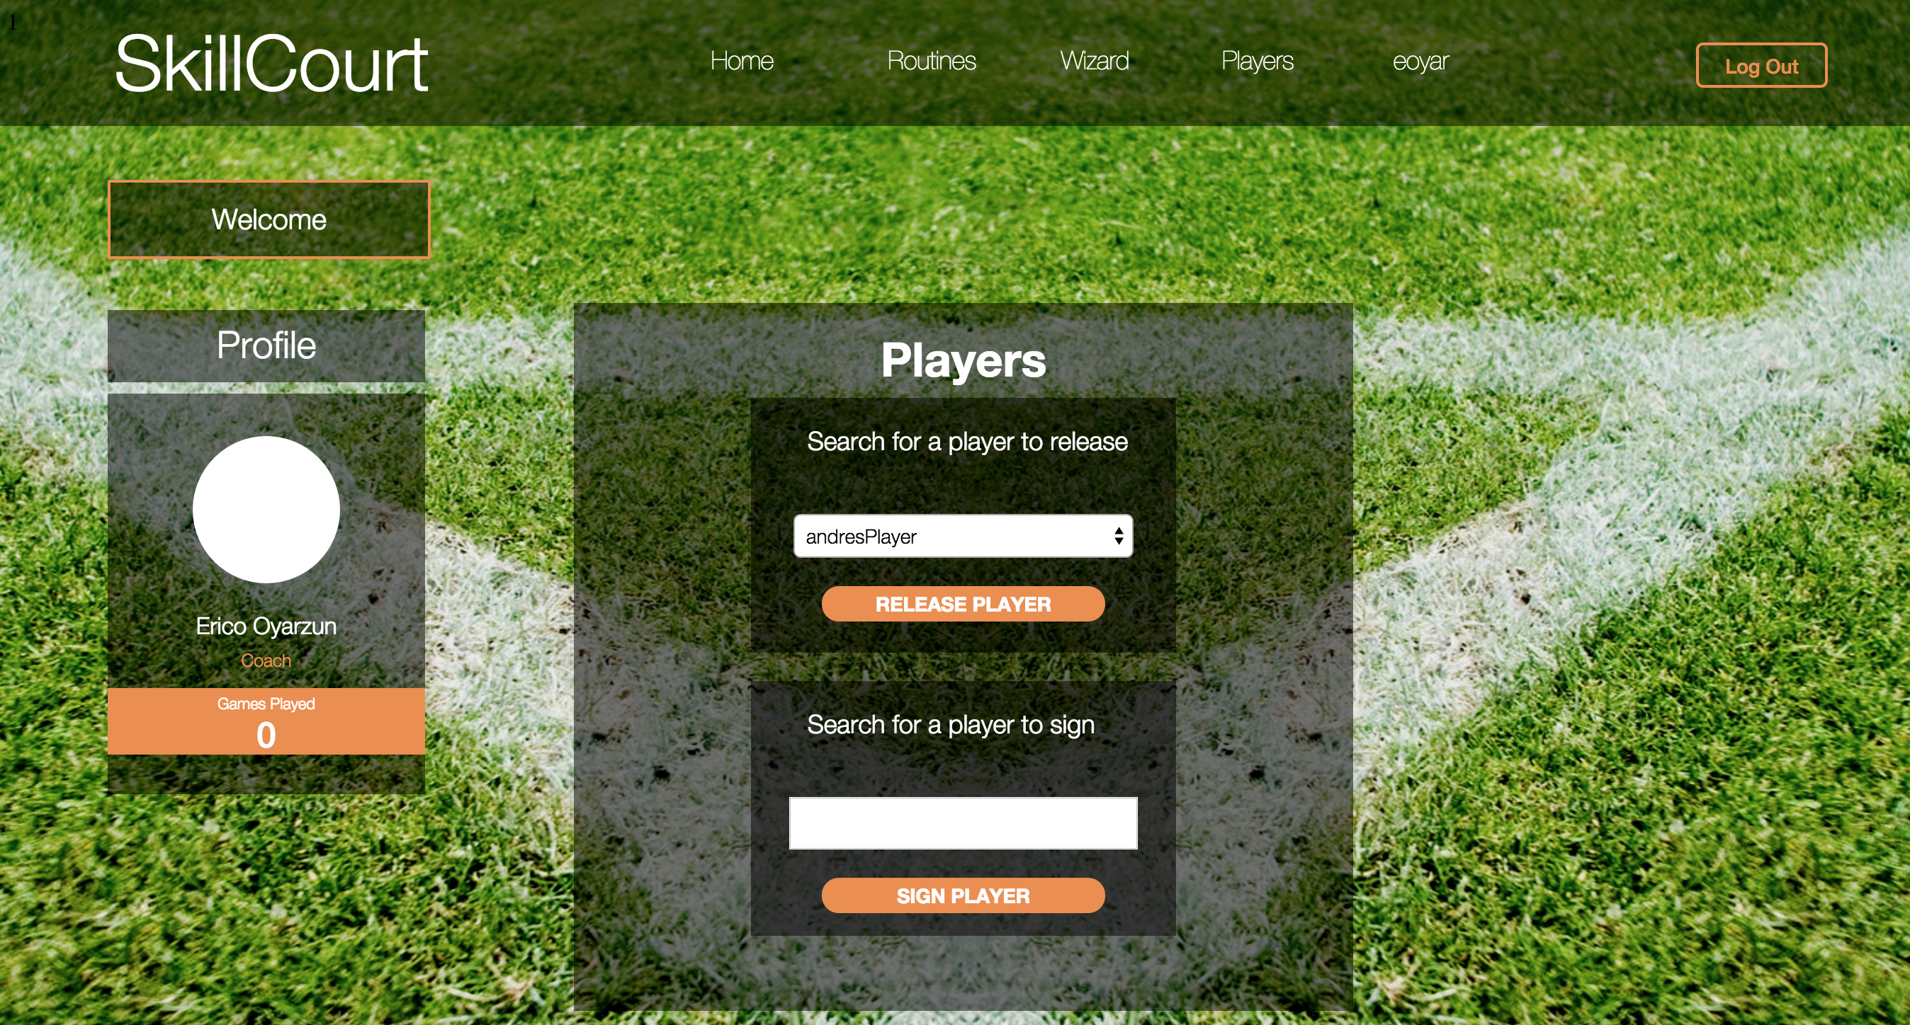

1. To sign a player, type an existing player’s username and click the “SIGN PLAYER” button. The system will show a warning if there was an error, or a successful alert message if it was successful.
2. To release a player, select a username from the dropdown menu and click the “RELEASE PLAYER” button. The system will show a warning if there was an error, or a successful alert message if it was successful.

#### Assign or un-assign a Player

1. The coach has the ability to assign and un-assign custom routines to the signed players. In the navigation bar, click the Routines button in the navigation bar.

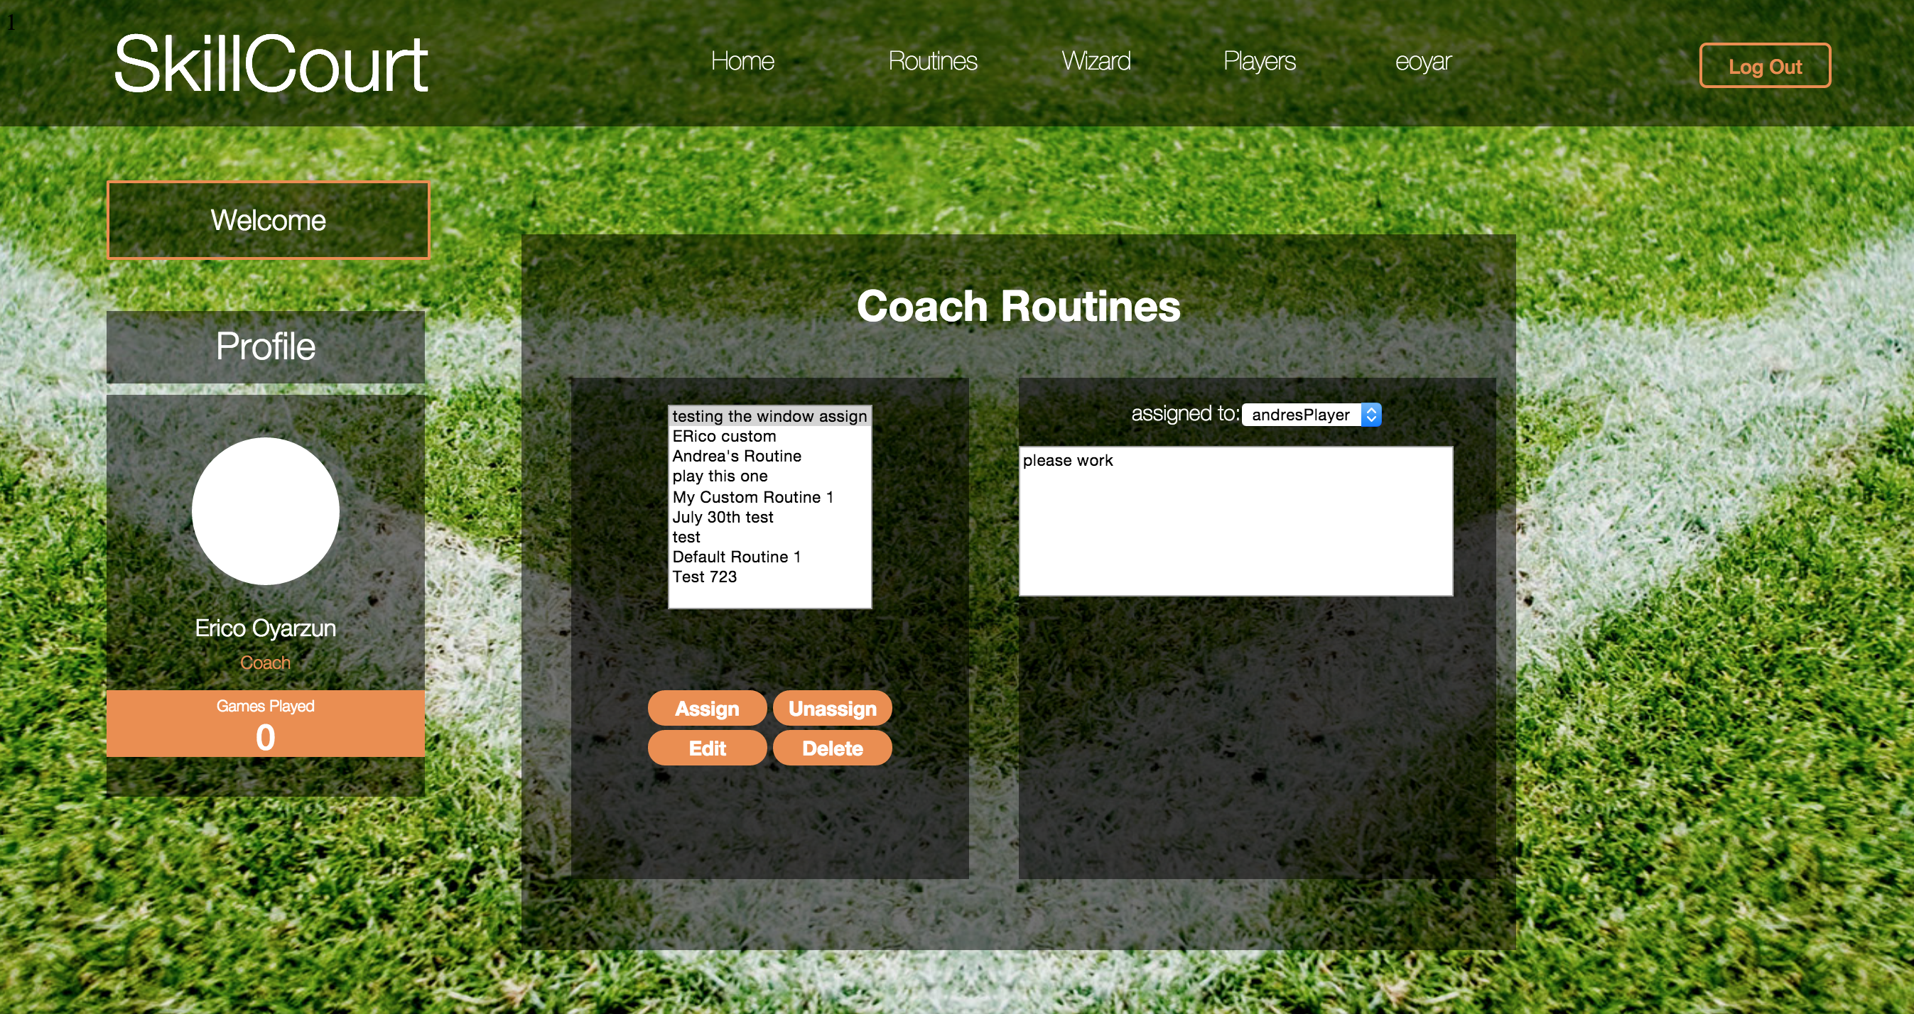

1. To assign a routine to a player, select a routine from the table and click the “Assign” button. The system will open a table to show all available signed players.

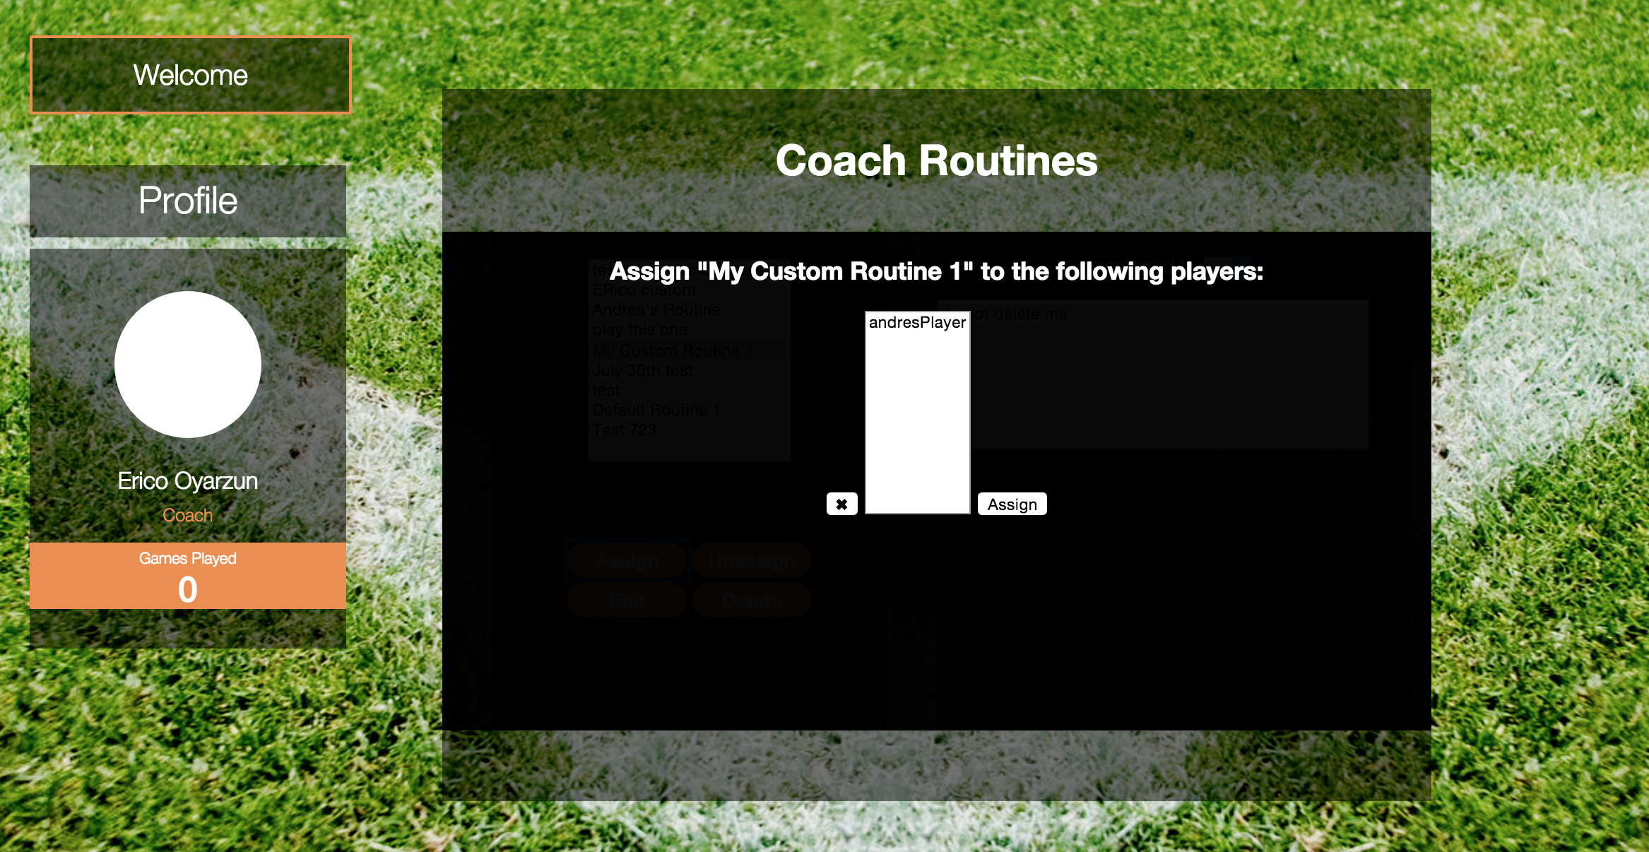

1. Select a player and click the “Assign” button. The website should redirect you to the Routines page.
2. To un-assign a routine to a player, select a routine from the table and click the “Unassign” button. The system will open a table to show all assigned players to that routine.

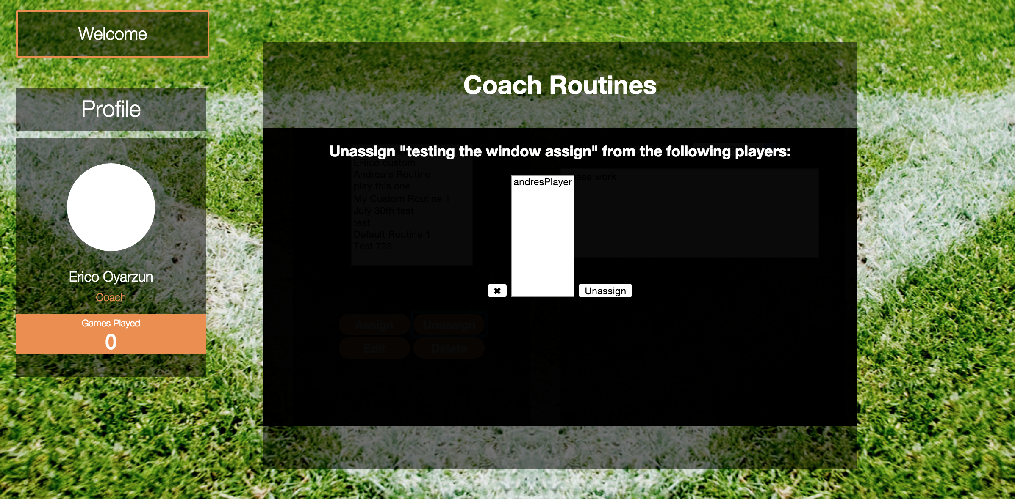

1. Select a player and click the “Unassign” button. The website should redirect the user to the Routines page.

#### Delete or Edit a Routine

1. To delete a routine, it must have no players assigned to it. In the Routines page, select a routine from the table and click the “Delete” button.

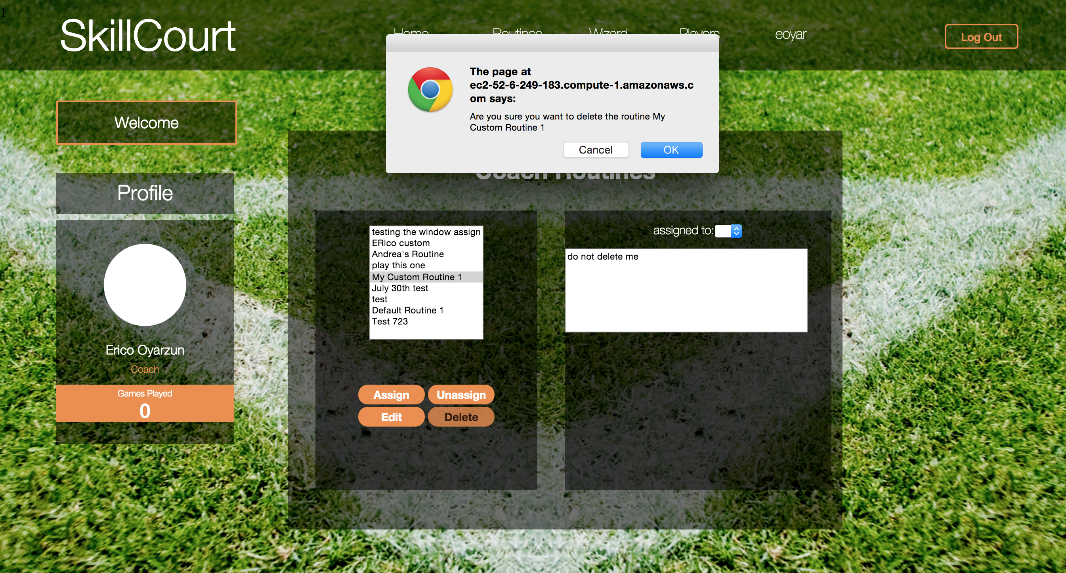

1. The system should prompt asking if you are sure to delete that routine. When you click the “OK” button, the system should refresh the Routines page to show the recently deleted routine.



1. To edit a routine, select a routine from the Routines page and click the “Edit” button. The website should redirect the user to the Wizard page, populating the options.

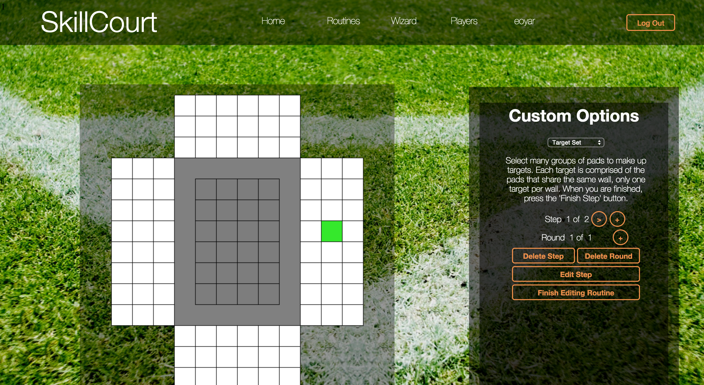

1. In the Wizard page, the coach can add, edit and delete steps. After finishing editing the routine, click the “Finish Editing Routine” button. This should take you back to the Routine page.

### Create a Custom Routine

1. In the navigation bar, click on the Wizard button. This should redirect the user to the Wizard page.
2. The wizard provides the ability to create custom routines. A coach has the ability to create a “Target Set” or a “Ground Step”. Select any of them, and click on the available pads. The clicked pads will light green.

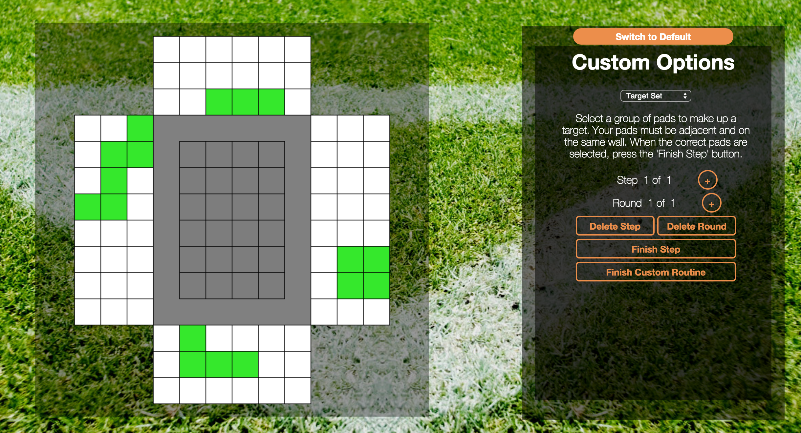

1. To finish the routine, click on the “Finish Step” button and then on the “Finish Custom Routine” button. This should redirect the user to the Complete Routine Creation page.

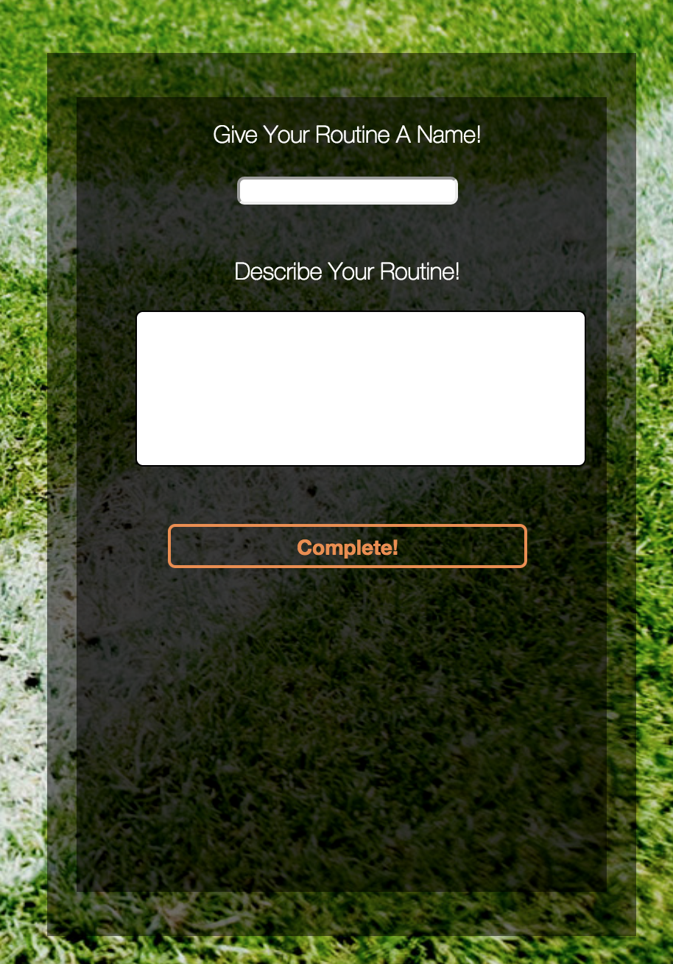

1. Fill in the routine name, as well as the routine description and click the “Complete!” button. After completing the routine, the website should redirect you to the Routines Page.

# 

# User Account Information

1. To view a user’s profile information, click the username button on the navigation bar. This should redirect the user to the Player Profile Page.

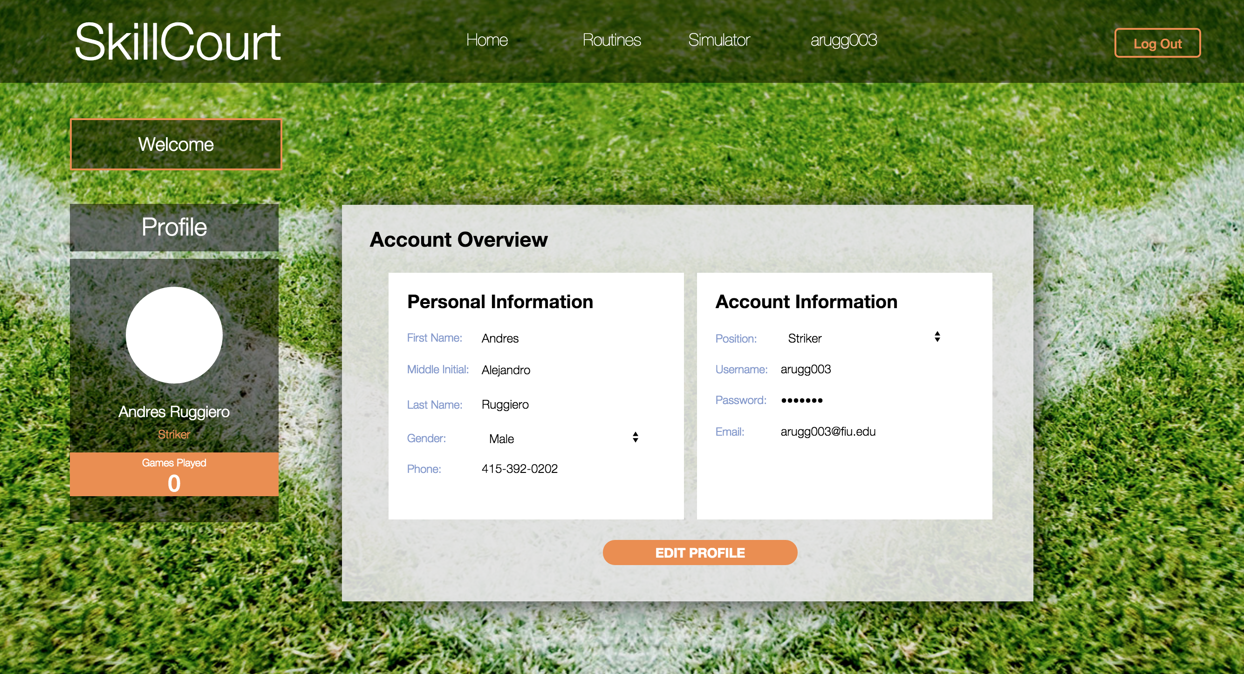

1. To edit a player’s account information, click the “Edit Profile” link. Change the information from the available fields, and click the “Save” button.

### Forget Password or Username

## Click on the Log In button on the Main page of the website. The website should redirect the user to the Log In Page.

## Macintosh HD:Users:andresruggiero:Desktop:Screen Shot 2015-07-30 at 2.17.13 PM.png

## Click on the “Forgot your username or password” link. This should redirect the user to the Reset Password Page.

## Macintosh HD:Users:andresruggiero:Desktop:Screen Shot 2015-07-30 at 3.44.16 PM.png

## Enter your email address and click the “Send” button. This should send and password reset email to your account. Click the link and reset your password